What is Modeshift Stars?
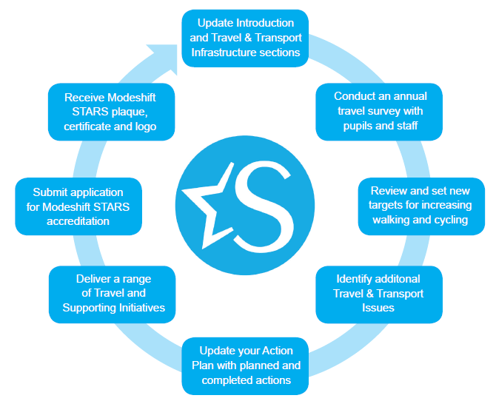
- Modeshift Stars is a free National Schools Award Scheme that recognises and rewards schools for promoting active travel to and from school, for example running and cycling.
- A personalised travel plan is created for individual schools, promoting the use of sustainable, healthy travel to and from School. The results of such changes are displayed professionally in the form of graphs and charts so that improvements in travel can be monitored easily.
- Over 12,000 schools represented by 53 organisations are currently seeing the benefits of using Modeshift stars to change the way that pupils travel to school.
- Bronze, Silver and Gold Accreditation is awarded to schools that are making significant changes towards Active Travel.
How is Accreditation achieved?
Bronze Accreditation-
- Completed Introduction, Travel & Transport Infrastructure
- Hands up surveys of at least 80% of pupils and 50% of staff
- Set at least 2 targets
Silver Accreditation
- Working group
- Modal shift away from the car
- Initiatives must have evidence
Gold Accreditation
- At least 5% shift away from car use.
- Evidence of funding
- ‘Gold standard’ initiative

To start using Modeshift Stars and obtain your unique travel plan, head to: https://modeshiftstars.org

