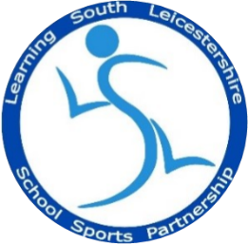
LSLSSP Year 3/4 Quicksticks Results

Well done to all teams that took part in the Yr 3/4 Quicksticks Finals at Brockington College. The final results are as follows:

Position | Team
1st | Swinford (B&H Qualifier)
2nd | Brocks Hill A (O&W Qualifier)
3rd | Badgerbrook A
4th | South Kilworth
5th | St. Josephs
6th | Kibworth
7th | Brocks Hill B
7th | Badgerbrook B

