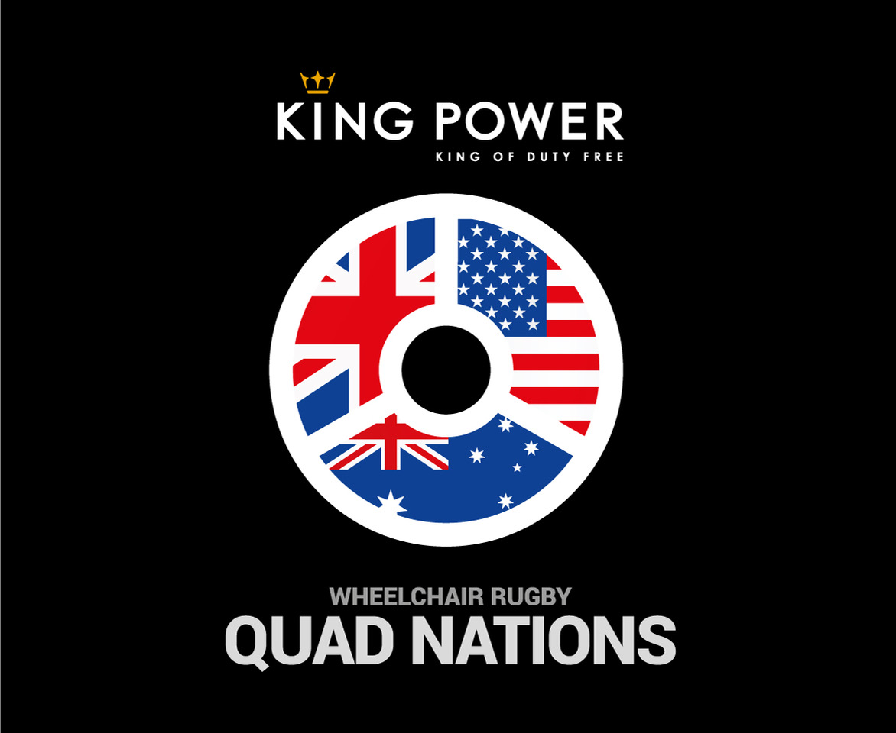

**See the World’s best Wheelchair Rugby teams**

Great Britain Wheelchair Rugby is hosting the 3rd King Power Quad Nations from February 21-23 at the Morningside Leicester Arena. This tournament features the reigning European Champions – **Great Britain**, taking on the two best teams in the World – reigning Paralympic champions **Australia** and Rio 2016 Silver medallists the **USA** as the teams prepare for the Tokyo 2020 Paralympics

All teams will play each over 3 days and we are delighted to offer local schools and colleges the opportunity to come and watch at a special double header session where GB will take on the USA and Australia and the USA will replay the Rio 2016 Gold medal match as the tournament curtain raiser.

**Date:** Friday 21st February. Doors open 0930

**Time:** 1100 – Australia v USA

1500 – Great Britain v USA

**Venue:** Morningside Leicester Arena

Total quantity of tickets required for children/students @£1

Quantity of tickets required for staff/accompanying adults (free)

Bus parking required on site (free) **Y/N** Number of Accessible seating places required

Contact name………………………………………. Email…………………………………………………….

Please email form to [info@wrquadnations.com](mailto:info@wrquadnations.com) by Feb 10th and we will send invoice for payment. All places subject to availability. There will be autograph opportunities and refreshments available at the venue. All tickets will be available on a first come first served basis.

For more event information please visit [www.wrquadnations.com](http://www.wrquadnations.com)