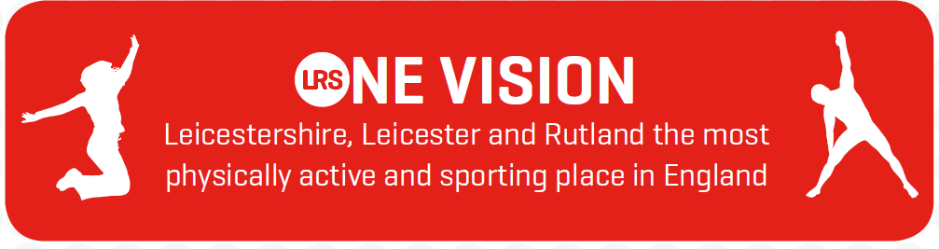

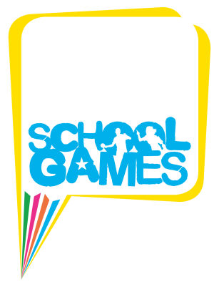
Press Release
Summer sun shines on School Games finale

The Leicester-Shire & Rutland School Games Summer Championships, the finale to the 2017/18 programme, took place at Uppingham School Sports Centre for the second year running on Friday 29th June. Over 1,000 primary aged athletes from 65 schools across Leicestershire, Leicester and Rutland competed in the glorious weather.

All schools were representing their School Sport & Physical Activity Network (SSPANs), having pre-qualified from Level 2 area finals to compete in the 12 competitions across 8 sports.

The Championships started with the Opening Ceremony and featured a gripping Judo demonstration performed by GO GOLD athletes Mary Tomblin and James Reseigh on stage. Compere Gaynor Nash and special guest Sam Ruddock, F35 Shot Put Silver Medallist then introduced the mascot race between ‘Zoom’ from the newly launched programme the Daily Boost, ‘Dazzle’ the School Games mascot, ‘Bobby’ from Boost Trampoline Park Leicester and Leo the Leicester-Shire & Rutland Sport lion, who won the hotly contested race!

The sun continued to shine as athletes set off for a competitive day of action in Quadkids Athletics, Kwik Cricket, Quicksticks Hockey, Netball, Sportsability, Swimming, Tri-Golf and the Change 4 Life Festival.

As results from the individual competitions began to filter in, the athletes gathered once again for the Closing Ceremony and were joined by Ben Higgins, 400m hurdler from Rutland and GO GOLD Ambassador, and former Leicester Tigers and England U21 Rugby player Matt Hampson.

The results were then announced, and trophies presented to the Champions and Spirit of the Games winners of each competition, and medals given out to Gold, Silver and Bronze medallist teams.

The finale to the Closing Ceremony saw Blaby & Harborough crowned the 2017/18 School Games Champions, topping the Medals table with 258 points. The Spirit of the Games Champions trophy was shared between South Charnwood and West Leicester, who both received 6 Spirit of the Games trophies over the year for best displaying the School Games values of - Determination, Honesty, Passion, Respect, Self-Belief and Teamwork.

Matty Crackell, Sports Development Officer at Leicester-Shire & Rutland Sport reflected on the day: “I thought it was an excellent day with perfect weather. There were lots of smiles on show and it was great to be able to culminate the School Games this year with a successful and well attended Summer Championships. The level of competition was very high, and each school should be proud of their efforts”.

Young athlete, Charlie, who represented the Blaby & Harborough SSPAN and competed in the Kwik Cricket competition, commented: “Every match is fun because everyone has a chance to bowl and bat and everyone was fair. I would definitely come back next year!”

School Games action doesn’t stop there, as Loughborough University are once again hosting the National School Games from 30th August – 2nd September 2018, where the country’s most talented young athletes compete, with exclusive opportunities available for local Primary and Secondary Schools, including £1 tickets!
The Leicester-Shire & Rutland School Games, now in its seventh year, is part of the national 'School Games Programme'. It aims to keep competitive sport at the heart of schools and provide more young people with the opportunity to compete and achieve their personal best.

Results
(See separate Results Document for full results)

Blaby & Harborough crowned ‘2017/18 School Games Champions’.

South Charnwood and West Leicester crowned ‘2017/18 School Games Spirit of the Games Champions’.

Quadkids Athletics Year 3/4 Mixed
- Winners: North West Leicestershire
- Spirit of the Games Winners: Rutland

Quadkids Athletics Year 5/6 Mixed
- Winners: North West Leicestershire
- Spirit of the Games Winners: Rutland

Kwik Cricket Year 5/6 Girls
- Winners: North Charnwood
- Spirit of the Games Winners: West Leicester

Kwik Cricket Year 5/6 Mixed
- Winners: West Leicester
- Spirit of the Games Winners: South Charnwood

Quicksticks Hockey Year 3/4 Mixed
- Winners: North West Leicestershire
- Spirit of the Games Winners: South Charnwood

Quicksticks Hockey Year 5/6 Mixed
- Winners: East Leicester
- Spirit of the Games Winners: South Charnwood

Netball Year 5/6 High 5 Mixed
- Winners: East Leicester
- Spirit of the Games Winners: South Charnwood

Sportsability Key Stage 2 Mixed Pan Disability
- Winners: Blaby & Harborough
- Spirit of the Games Winners: Hinckley & Bosworth

Swimming Year 5/6 Mixed
- Winners: Blaby & Harborough
- Spirit of the Games Winners: Melton & Belvoir

Tri-Golf Year 3/4 Mixed
- Winners: North West Leicestershire
- Spirit of the Games Winners: North Charnwood

Tri Golf Year 5/6 Mixed
- Winners: North West Leicestershire
- Spirit of the Games Winners: Oadby & Wigston

Change 4 Life Festival Year 3/4 Mixed (non-competitive)
- Spirit of the Games Winners: Rutland

For more information and to ensure your School is involved next academic year visit www.lrsport.org/schoolgames

~ End ~

Notes to Editors
Photographs: As detailed in email. Additional photographs available upon request.

- See attached for full results.

- The Spirit of the Games Trophy is awarded to the Team that best showed the School Games values of - Determination, Honesty, Passion, Respect, Self-Belief and Teamwork.

- Delivered locally by Leicester-Shire & Rutland Sport (LRS) and the 10 School Sport & Physical Activity Networks (SSPANs), the Leicester-Shire & Rutland School Games provides schools the chance to boost their existing work in school sport to create a year-round calendar of competition for all students.

- Quadkids Athletics: Year 3/4 and Year 5/6 Mixed
- Kwik Cricket: Year 5/6 Mixed and Girls
- Quicksticks Hockey: Year 3/4 and Year 5/6 Mixed
- Netball: Year 5/6 High 5 Mixed
- Sportsability: Key Stage 2 Mixed Pan Disability
- Swimming: Year 5/6 Mixed
- Tri-Golf: Year 3/4 and Year 5/6 Mixed
- Change 4 Life Festival (participation): Year 3/4 Mixed

For more information contact:
Leicester-Shire and Rutland Sport (LRS)
Name: Matty Crackell, Sports Development Officer
Tel: 01509 564865
Email: info@lrsport.org / m.crackell@lrsport.org
Or visit: www.lrsport.org/schoolgames

Leicester-Shire & Rutland Sport (LRS)
Leicester-Shire & Rutland Sport is your local network and support team for physical activity and sport across Leicestershire, Leicester and Rutland. We want to be the most active place in England, building a healthy and vibrant future for our communities.
Working in partnership, we have a shared commitment to enrich the lives of the residents of LLR by:
- Getting more people to take part in physical activity and sport.
- Improving our citizen's physical and mental well-being.
- Developing our paid and unpaid workforce.
- Creating a strong voice for physical activity and sport.
- Building a physical activity and sport environment that is safe, fair and customer focused.

County Sports Partnerships (CSPs) like LRS have been set up by Sport England as the delivery system for the development of sport and physical activity at a county level, ensuring national resources have local reach.
For more information visit www.lrsport.org

